**Rail way-Ticket Booking System**

**A Project Report**

***Submitted by***

## E045 – Tarun Surani

## E051 – Malhar Trivedi

## E054 – Raghav Verma

***Under the Guidance of***

**Prof. Kamal Mistry**

**Prof. Mohini Reddy**

***In the partial fulfillment for the award of the degree of***

## B-Tech.

**in Computer Engineering – 2022**

At



**MUKESH PATEL SCHOOL OF TECHNOLOGY**

**MANAGEMENT &ENGINEERING**

**SVKM’s NARSEE MONJEE INSTITUTE OF MANAGEMENT STUDIES**

**(Declared as Deemed-to-be University Under Section 3 of the UGC Act, 1956)**

V. L. Mehta Road, Vile Parle (West)

MUMBAI -400056

**April 2020**

## CERTIFICATE

This is to certify that the project entitled “**Rail way-Ticket Booking System**” is the bonafide work carried out by **E045 E051** **E054** of B-Tech, MPSTME (NMIMS), Mumbai, during the IV semester of the academic year **2019-2020**, in partial fulfillment of the requirements for the Course Programming Language.

___________________

Prof. Kamal Mistry

Internal Mentor

_______________________ ________________________

Examiner 1 Examiner 2

## DECLARATION

I, Raghav Verma, Roll No. E054, B-Tech (Computer Engineering), IV semester understand that plagiarism is defined as anyone or combination of the following:

1. Un-credited verbatim copying of individual sentences, paragraphs or illustration (such as graphs, diagrams, etc.) from any source, published or unpublished, including the internet.
2. Un-credited improper paraphrasing of pages paragraphs (changing a few words phrases, or rearranging the original sentence order)
3. Credited verbatim copying of a major portion of a paper (or thesis chapter) without clear delineation of who did wrote what. ( Source: IEEE, The institute, Dec. 2004)
4. I have made sure that all the ideas, expressions, graphs, diagrams, etc., that are not a result of my work, are properly credited. Long phrases or sentences that had to be used verbatim from published literature have been clearly identified using quotation marks.
5. I affirm that no portion of my work can be considered as plagiarism and I take full responsibility if such a complaint occurs. I understand fully well that the guide of the seminar/ project report may not be in a position to check for the possibility of such incidences of plagiarism in this body of work.

Signature of the Students: __________, _____________, ____________, ______________

Names: Tarun Surani, Malhar Trivedi, ,Raghav Verma

Roll Nos. : E045, E051, E054

Place: Mumbai

Date: 5/04/20

**Acknowledgement**

I would like to express my special thanks of gratitude to my teacher Kamal Mistry who gave me the opportunity to do this project on the topic Railway ticket booking system which also helped me in doing a lot of Research and I came to know about so many new things I am really thankful to them.

I would also like to thank Prof. Mohini Reddy for guiding us through the implementation of the project and helping us through process.  
Secondly, I would also like to thank my friends who helped me a lot in finalizing this project within the limited time frame.

## Table of contents

**CHAPTER NO. TITLE PAGE NO.**

1. INTRODUCTION
2. SOFTWARES AND API USED WITH DESCRIPTION
3. METHODS IMPLEMENTED
4. SCREENSHOTS
5. CONCLUSION & FUTURE SCOPE
6. SOCIETAL APPLICATION

**Introduction**

Indian Railways (IR) is India's national railway system operated by the Ministry of Railways. It manages the fourth-largest railway network in the world by size, with 121,407 kilometres (75,439 mi) of total track over a 67,368-kilometre (41,861 mi) route. IR runs more than 20,000 passenger trains daily, on both long-distance and suburban routes, from 7,349 stations across India. The trains have a five-digit numbering system. In the freight segment, IR runs more than 9,200 trains daily.

Indian Railway Catering and Tourism Corporationis a subsidiary of the Indian Railways that handles the catering, tourism and online ticketing operations of the Indian railways, with around 5,50,000 to 6,00,000 bookings every day is the world's second busiest. It's tagline is "Lifeline of the nation".

It is known for changing the face of railway ticketing in India. It pioneered internet-based rail ticket booking through its website, as well as from the mobile phones via Wi-Fi, GPS. In addition to e-tickets, Indian Railways Catering and Tourism Corporation also offers I-tickets that are basically like regular tickets.

The Indian Railways (IR) carries about 5.5 lakhs passengers in reserved accommodation every day. The Computerised Passenger Reservation System facilitates the booking of tickets from any of the 4 terminals. These tickets can be booked for journeys commencing in any corner of India and ending in the consequent one, with travel time as long as 24 hours and distance up to several thousand kilometres.

In the given project we will be developing a MySQL Database which will help users to find train details, enquire about trains running between given two stations, book tickets and know the exact rates of their tickets to the desired destination. The user also can use the chatbot to get assistance.

With the help of online booking people can book their tickets online through internet, sitting in their home by a single click of mouse.

The main objective of the project is management of the database of Railway System. This is done by creating database of the trains between various stations, user database, booking database and many more. The database is then connected to main program using interconnection of the program with the database using Python.

To access this Railway Ticket Booking System Project , users have to register by giving their entire details such as their name, full address details, sex, age, date of birth, nationality, mobile number, email id. After successful registration, users will be provided with their login id and password. The Ticket Management System has applicants and administrators.

**Software and API**

**Software:**

* Pycharm Community Edition 2019.3.1
* MySQL Workbench 8.0 CE

**Libraries:**

* Tkinter – For GUI :

The tkinter package (“Tk interface”) is the

standard Python interface to the Tk GUI toolkit.

The Tk interface is located in a binary module

named _tkinter.

* MySQL-connector – For connecting GUI and MySQL
* Date-time

**Methods Implemented**

|  |  |  |
| --- | --- | --- |
| **S.No.** | **Method** | **Description** |
| 1. | Sign-up/login | Allows to user to register or sign as a customer or an admin |
| 2. | Admin | Let’s the user monitor the project and add trains between any two stations |
| 3. | Search | Asks the user to input details for the journey and gives the output as the available trains |
| 4. | Booking | Leads the user to the payment and confirmation page after getting the passenger details |
| 5. | Payment | Gives the user options for paying for the ticket and gives a confirmation |
| 6. | Ticket info | Given the ticket id. Shows the output of details of the passenger and the journey |

**Screenshots**

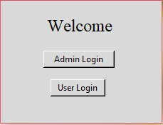

The first page that opens, welcomes the user and asks if they want to log in as an admin or as a user. An admin has the liberty to add a train or delete one to between the given cities. But as a user you can only search trains, book tickets and view ticket information. Clicking the user login leads to the next page.

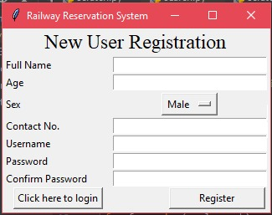

As a user you can either log in if your credentials have already been registered earlier, or you can register yourself by providing the details about your name, age, sex, contact etc.

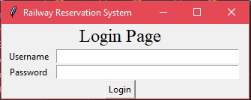

If already registered you can login and proceed to search trains page which is the main functionality of the project.

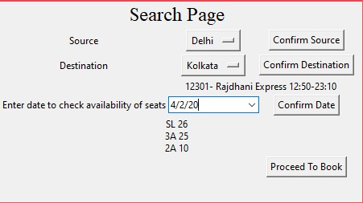

The user is asked for the details of the date of journey for which a calendar pops up and lets you select the date and the source and destination are taken from the user and the available trains are shown. Along with that the number of seats available in each class are also shown.

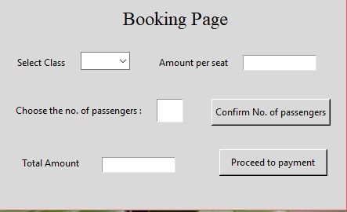

Once the trains are searched, the next page leads you to an option of booking a ticket which asks for your travel preferences and shows the price on the same page as well.

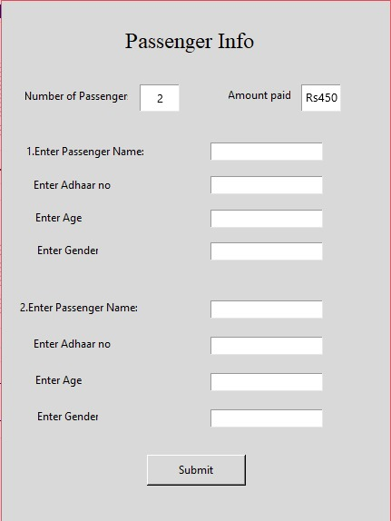

Once the travel prefrences for the ticket are determined the project asks for the users/passengers information in order to book the ticket.

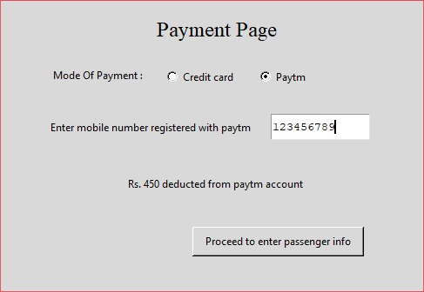

Different modes of payment options are provided to the user and once the payment confirmation is done, the booking confirmation is shown. After this the user can opt to vie the ticket details or end the session.

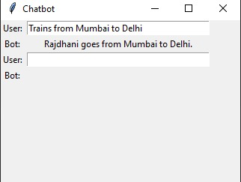

The chatbot assists the user with whatever navigation he needs in the project and responds with the details already fed in to it.

**Conclusion and Future Scope**

Indian Railway Catering and Tourism Corporation (IRCTC) is a subsidiary of the Indian Railways that handles the catering, tourism and online ticketing operations of the Indian railways, with around 5,50,000 to 6,00,000 bookings every day is the world's second busiest. It's tagline is "Lifeline of the nation". It is known for changing the face of railway ticketing in India. Databases are used to support internal operations of organizations and to underpin online interactions with customers and suppliers. Databases are used to hold administrative information and more specialized data, such as engineering data or economic models. Examples include computerized library systems, flight reservation systems, computerized parts inventory systems, and many content management systems that store websites as collections of webpages in a database. We have tried to implement a part of IRCTC and it has helped us to understand how Database is managed in the website.

In ode make this project further useful and to put it to good use, we can add the features to cancel tickets, make a chat bot to assist the user, add a functionality to see where the train has reached in real time and add some streaming platforms for the user to enjoy their travel while being offline.

**Societal Applications**

The trend of advancement in technology has prevailed for very long and has brought about as paradigm shift in the nature of the man. The railway ticket booking system lets the user sit at home and plan a trip to any part of the country via the railway lines and facilitates the ease of knowing the details of the trip. It enables the user to, as an admin, add a train in the database as well. It gives and easier option to book tickets on a simple mouse click.